The following quotation formatted pdf is currently created by the form view code just below this picture. Note that the code was changed slightly by me, so it is slightly different from the original odoo installation code.

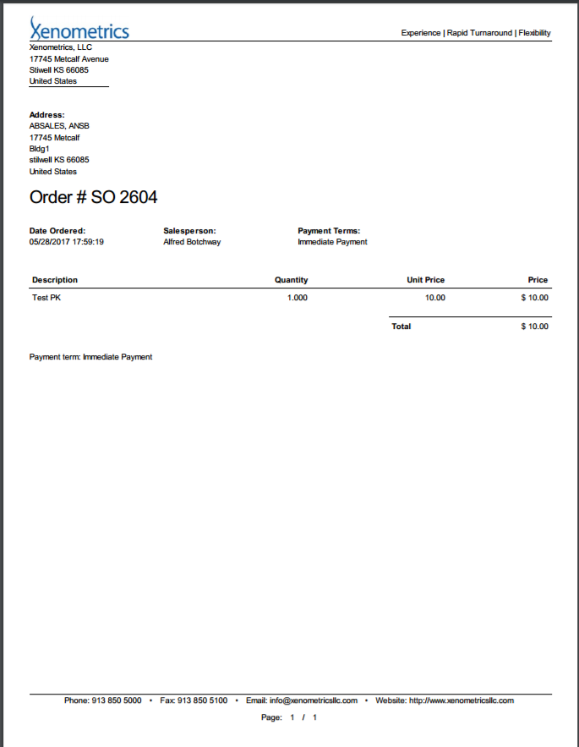

=============CODE FOR CURRENT QUOTATION FOR REFERENCE ONLY===============

<?xml version="1.0"?>

<form string="Sales Order" class="o_sale_order">

<header>

<button name="288" string="Create Invoice" type="action" class="btn-primary" attrs="{'invisible': [('invoice_status', '!=', 'to invoice')]}"/>

<button name="288" string="Create Invoice" type="action" context="{'default_advance_payment_method': 'percentage'}" attrs="{'invisible': ['|',('invoice_status', '!=', 'no'), ('state', '!=', 'sale')]}"/>

<button name="action_quotation_send" string="Send by Email" type="object" states="draft" class="btn-primary"/>

<button name="print_quotation" string="Print" type="object" states="draft" class="btn-primary"/>

<button name="action_confirm" states="sent" string="Confirm Sale" class="btn-primary o_sale_confirm" type="object"/>

<button name="action_confirm" states="draft" string="Confirm Sale" class="o_sale_confirm" type="object"/>

<button name="print_quotation" string="Print" type="object" states="sent,sale"/>

<button name="action_quotation_send" string="Send by Email" type="object" states="sent,sale"/>

<button name="action_cancel" states="draft,sent,sale" type="object" string="Cancel"/>

<button name="action_draft" states="cancel" type="object" string="Set to Quotation"/>

<button name="action_done" type="object" string="Lock" states="sale" help="If the sale is locked, you can not modify it anymore. However, you will still be able to invoice or deliver."/>

<field name="state" widget="statusbar" statusbar_visible="draft,sent,sale"/>

</header>

<sheet>

<div class="oe_button_box" name="button_box">

<button name="action_view_invoice" type="object" class="oe_stat_button" icon="fa-pencil-square-o" attrs="{'invisible': [('invoice_count', '=', 0)]}">

<field name="invoice_count" widget="statinfo" string="Invoices"/>

</button>

</div>

<div class="oe_title">

<h1>

<field name="name" readonly="1"/>

</h1>

</div>

<group>

<group>

<field name="partner_id" domain="[('customer','=',True)]" context="{'search_default_customer':1, 'show_address': 1}" options="{&quot;always_reload&quot;: True}"/>

<field name="partner_invoice_id" groups="sale.group_delivery_invoice_address" context="{'default_type':'invoice'}"/>

<field name="partner_shipping_id" groups="sale.group_delivery_invoice_address" context="{'default_type':'delivery'}"/>

</group>

<group>

<field name="date_order" attrs="{'invisible': [('state', 'in', ['sale', 'done', 'cancel'])]}"/>

<field name="validity_date" attrs="{'invisible': [('state', 'in', ['sale', 'done'])]}"/>

<field name="confirmation_date" attrs="{'invisible': [('state', 'in', ['draft', 'sent', 'cancel'])]}"/>

<field name="pricelist_id" groups="product.group_sale_pricelist"/>

<field name="currency_id" invisible="1"/>

<field name="payment_term_id" options="{'no_create': True}"/>

</group>

</group>

<notebook>

<page string="Order Lines">

<field name="order_line" mode="tree,kanban" attrs="{'readonly': [('state', 'in', ('done','cancel'))]}">

<form string="Sales Order Lines">

<group>

<group>

<field name="product_id" context="{'partner_id':parent.partner_id, 'quantity':product_uom_qty, 'pricelist':parent.pricelist_id, 'uom':product_uom, 'company_id': parent.company_id}" attrs="{'readonly': ['|', ('qty_invoiced', '&gt;', 0), ('procurement_ids', '!=', [])]}"/>

<field name="layout_category_id" groups="sale.group_sale_layout"/>

<field name="invoice_status" invisible="1"/>

<field name="qty_to_invoice" invisible="1"/>

<field name="qty_delivered_updateable" invisible="1"/>

<field name="procurement_ids" invisible="1"/>

<field name="price_subtotal" invisible="1"/>

<label for="product_uom_qty" string="Ordered Quantity"/>

<div>

<field context="{'partner_id':parent.partner_id, 'quantity':product_uom_qty, 'pricelist':parent.pricelist_id, 'uom':product_uom, 'uom_qty_change':True, 'company_id': parent.company_id}" name="product_uom_qty" class="oe_inline"/>

<field name="product_uom" groups="product.group_uom" class="oe_inline oe_no_button" attrs="{'readonly': [('state', 'in', ('sale','done', 'cancel'))]}"/>

</div>

<label for="qty_delivered" string="Delivered Quantity" invisible="context.get('hide_sale')"/>

<div invisible="context.get('hide_sale')">

<field name="qty_delivered" attrs="{'readonly': [('qty_delivered_updateable', '=', False)]}"/>

</div>

<label for="qty_invoiced" string="Invoiced Quantity" invisible="context.get('hide_sale')"/>

<div invisible="context.get('hide_sale')">

<field name="qty_invoiced" invisible="context.get('hide_sale')"/>

</div>

<field name="price_unit"/>

<label for="discount" groups="sale.group_discount_per_so_line"/>

<div name="discount" groups="sale.group_discount_per_so_line">

<field name="discount" class="oe_inline"/> %

</div>

</group>

<group>

<field name="tax_id" widget="many2many_tags" domain="[('type_tax_use','=','sale'),('company_id','=',parent.company_id)]" attrs="{'readonly': [('qty_invoiced', '&gt;', 0)]}"/>

<label for="customer_lead"/>

<div>

<field name="customer_lead" class="oe_inline"/> days

</div>

<label for="analytic_tag_ids"/>

<div>

<field name="analytic_tag_ids" widget="many2many_tags"/>

</div>

</group>

</group>

<label for="name"/>

<field name="name"/>

<div groups="base.group_no_one">

<label for="invoice_lines"/>

<field name="invoice_lines"/>

</div>

<field name="state" invisible="1"/>

</form>

<tree string="Sales Order Lines" editable="bottom" decoration-info="invoice_status=='to invoice'">

<field name="sequence" widget="handle"/>

<field name="product_id" attrs="{'readonly': ['|', ('qty_invoiced', '&gt;', 0), ('procurement_ids', '!=', [])]}" context="{'partner_id':parent.partner_id, 'quantity':product_uom_qty, 'pricelist':parent.pricelist_id, 'uom':product_uom, 'company_id': parent.company_id}"/>

<field name="layout_category_id" groups="sale.group_sale_layout"/>

<field name="name"/>

<field name="product_uom_qty" string="Ordered Qty" context="{'partner_id':parent.partner_id, 'quantity':product_uom_qty, 'pricelist':parent.pricelist_id, 'uom':product_uom, 'company_id': parent.company_id}"/>

<field name="qty_delivered" invisible="context.get('hide_sale')" attrs="{'readonly': [('qty_delivered_updateable', '=', False)]}"/>

<field name="qty_invoiced" invisible="context.get('hide_sale')"/>

<field name="qty_to_invoice" invisible="1"/>

<field name="product_uom" attrs="{'readonly': [('state', 'in', ('sale','done', 'cancel'))]}" context="{'company_id': parent.company_id}" groups="product.group_uom" options="{&quot;no_open&quot;: True}"/>

<field name="analytic_tag_ids" groups="analytic.group_analytic_accounting" widget="many2many_tags"/>

<field name="price_unit" attrs="{'readonly': [('qty_invoiced', '&gt;', 0)]}"/>

<field name="tax_id" widget="many2many_tags" domain="[('type_tax_use','=','sale'),('company_id','=',parent.company_id)]" attrs="{'readonly': [('qty_invoiced', '&gt;', 0)]}"/>

<field name="discount" groups="sale.group_discount_per_so_line"/>

<field name="price_subtotal" widget="monetary" groups="sale.group_show_price_subtotal"/>

<field name="price_total" widget="monetary" groups="sale.group_show_price_total"/>

<field name="qty_delivered_updateable" invisible="1"/>

<field name="procurement_ids" invisible="1"/>

<field name="state" invisible="1"/>

<field name="invoice_status" invisible="1"/>

<field name="customer_lead" invisible="1"/>

<field name="currency_id" invisible="1"/>

</tree>

<kanban class="o_kanban_mobile">

<field name="product_id"/>

<field name="product_uom_qty"/>

<field name="product_uom" groups="product.group_uom"/>

<field name="price_subtotal"/>

<templates>

<t t-name="kanban-box">

<div t-attf-class="oe_kanban_card oe_kanban_global_click">

<div class="row">

<div class="col-xs-12">

<strong><span><t t-esc="record.product_id.value"/></span></strong>

</div>

</div>

<div class="row">

<div class="col-xs-8 text-muted">

<span><t t-esc="record.product_uom_qty.value"/> <t t-esc="record.product_uom.value"/></span>

</div>

<div class="col-xs-4 text-muted">

<span class="pull-right text-right"><t t-esc="record.price_subtotal.value"/></span>

</div>

</div>

</div>

</t>

</templates>

</kanban>

</field>

<group class="oe_subtotal_footer oe_right" colspan="2" name="sale_total">

<field name="amount_untaxed" widget="monetary" options="{'currency_field': 'currency_id'}"/>

<field name="amount_tax" widget="monetary" options="{'currency_field': 'currency_id'}"/>

<div class="oe_subtotal_footer_separator oe_inline o_td_label">

<label for="amount_total"/>

<button name="button_dummy" states="draft,sent" string="(update)" type="object" class="oe_edit_only oe_link"/>

</div>

<field name="amount_total" nolabel="1" class="oe_subtotal_footer_separator" widget="monetary" options="{'currency_field': 'currency_id'}"/>

</group>

<field name="note" class="oe_inline" placeholder="Setup default terms and conditions in your company settings."/>

<div class="oe_clear"/>

</page>

<page string="Other Information">

<group>

<group string="Sales Information" name="sales_person">

<field name="user_id"/>

<field name="team_id" options="{'no_create': True}"/>

<field name="client_order_ref"/>

<field name="company_id" options="{'no_create': True}" groups="base.group_multi_company"/>

<field name="project_id" attrs="{'invisible':[('state','=','sale')]}" context="{'default_partner_id':partner_invoice_id, 'default_name':name}" groups="analytic.group_analytic_accounting"/>

<field name="related_project_id" attrs="{'readonly': ['|',('project_id','!=',False),('invoice_count','!=',0),('state','=','sale')],'invisible':[('state','!=','sale')]}" context="{'default_partner_id':partner_invoice_id, 'default_name':name}" groups="analytic.group_analytic_accounting"/>

</group>

<group name="sale_pay" string="Invoicing">

<field name="fiscal_position_id" options="{'no_create': True}"/>

<field name="invoice_status" attrs="{'invisible': [('state', 'not in', ('sale','done'))]}"/>

</group>

<group string="Reporting" name="technical" groups="base.group_no_one">

<field groups="base.group_no_one" name="origin"/>

</group>

</group>

</page>

</notebook>

</sheet>

<div class="oe_chatter">

<field name="message_follower_ids" widget="mail_followers"/>

<field name="message_ids" widget="mail_thread"/>

</div>

</form>

========================================CODE FOR REFERENCE=======

Required QUOTATION changes for now are

1. Move the quotation number field to the top right just beneath the tag line
2. Move the customer’s address to beneath the quote number
3. The word “sales person” to be replaced with “Account Manager” throughout the quote and anywhere in the CRM
4. Delete the second occurrence of the payment terms. Leave the first one that appears next to the “Account Manager” after that word replaces “sales person” in 3 above.
5. Add other columns

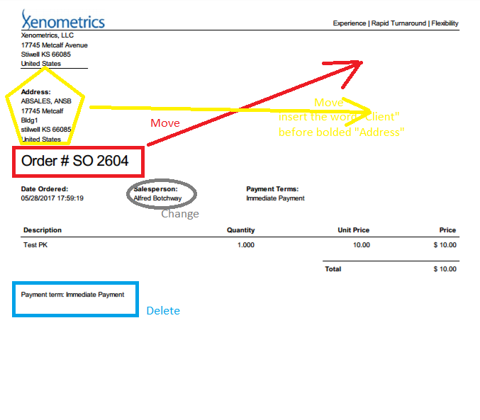

The current code produces the following for the quote detailed section. This section of the quote needs more customization

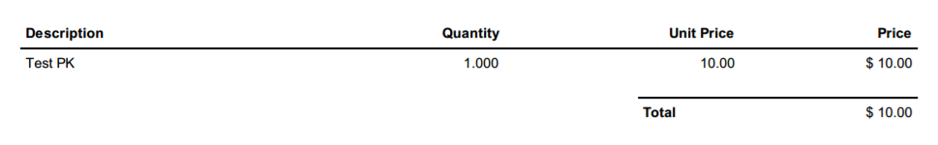

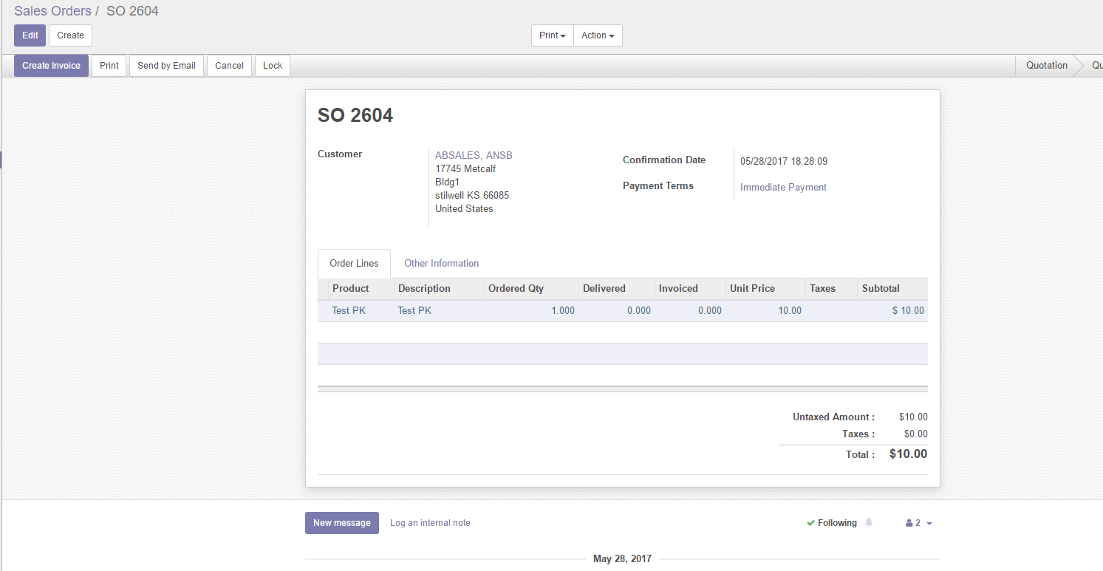

Required QUOTATION changes for now are;

1. By default, the Tax column must be set to Zero % for all quotations that are generated out of the odoo CRM software.
2. Once set to zero, comment out its display/view to the end user
3. Comment out “Delivered” from crm user’s view
4. Comment out “Invoiced” from crm user’s view
5. Insert a column called “Notes” for the crm user to be able to add the specific line item notes



1. Add additional email addresses to the footer of the quotation templates
2. The additional email addresses should be the [salesperson@company.com](mailto:salesperson@company.com); [contact1@company.com](mailto:contact1@company.com); contact2@company.com;

Ideally once the changes are made to the quotation template, the pdf document should look like the document attached and file named “current template 061717.doc”. It might be an idea to convert the attached into xml format to help with coding for the quotation section of odoo. Please suggest other ways for mimicking the attached quote template 061717.doc